How to Update Your Reveal16

- Unfold and plug your Reveal16 into a power outlet.
- Download the new update file from the HumanWare website under the SUPPORT tab, click on Reveal 16 on the left-hand side of the website and then click on Reveal 16 Version X.X on the right-hand side of the website. The download should start automatically. This file will be stored in your downloads folder.
- Use a USB cable to connect your Reveal16 to the computer that has the downloaded file. The cable should have a micro-USB connector on one end and a normal USB connector on the opposite end.
- The micro-USB port on the Reveal 16 can be found under the bridge of the device. Refer to the image below.
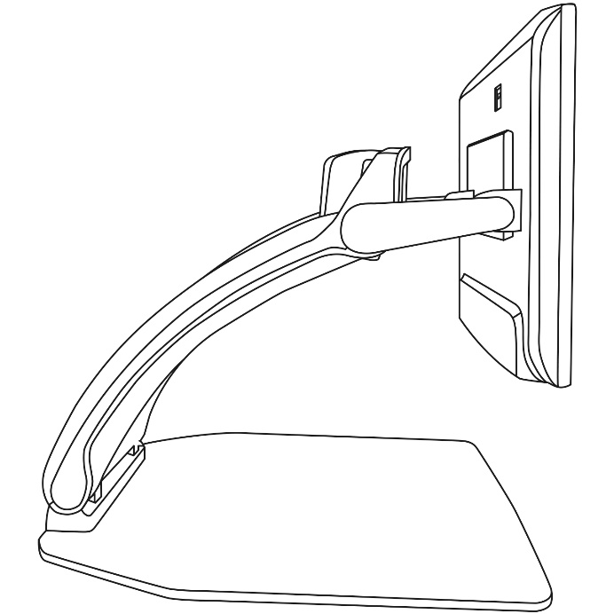

- Power on the device. A message should appear on the Reveal 16: PC Connected.
- On the computer a window should have appeared showing the root of the device.
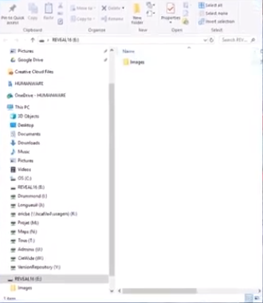

- Copy the downloaded file to the root of the Reveal 16.
- Disconnect the Reveal 16 from the Computer.
- Power OFF the Reveal 16.
- Power ON the Reveal 16. A message saying Software Update should appear.
- Confirm that the device has been updated correctly by pressing and holding the Contrast dial to go to the settings menu and scrolling down to the last option called About.
- If your device did not update correctly unplug and plug back your Reveal 16 from the wall outlet.

