# Picture of a BI 40X

# A HumanWare Brailliant BI X and an iOS Device

# A Productive Combination.

All of Apple's iOS devices, (iPod touch, iPhone and iPad,) have built in braille access when using the VoiceOver screen reader. Utilizing this braille access allows a user to receive braille output on a supported braille display, and if the display has input keys, one can actually control the iOS device without ever touching the device's touch screen. For simplicity, the term iPhone will be used throughout this document to represent the line of Apple's iOS devices. It is important to ensure that you have ios version 14.4 installed. If you are unable to install the update due to an older model, it will not be possible to connect the New Brailliant BI X as a braille display, this is because the New Brailliant BI X is using the latest type of connection.

HumanWare's New Brailliant line of Braille displays brings a sleek, ergonomic, productive and portable design to its user's fingertips. Developed with display lengths of 20 or 40 cells, and with built in Bluetooth connectivity, these displays are the perfect size for mobile productivity with iPhones, while providing enough Braille for tasks requiring a significant amount of reading.

Once the two tools are paired, the Brailliant can be used to produce braille output, along with providing control over the iPhone without using the touch screen. Users have the capability to:

* Wake up the ios device from your braille device
* Navigate applications, home screens, and other elements
* Select items
* Enter text into any editable applications such as text messages, emails, note files, etc, using the Brailliant's ergonomic braille input keys. Text can be entered in contracted or uncontracted braille.
* Read in braille from all accessible applications, including reading books from the iBooks application.
* In short, anything that could be accomplished with VoiceOver via the touch screen can be accomplished using the Brailliant's input keyboard

The Brailliant BI X can be paired with all iPhones running iOS 14.4 + as a Bluetooth Braille display. To connect the two devices, the pairing must be initialized from the Brailliant, just as you would pair with any other keyboard or Bluetooth device.

To make the connection, do the following:

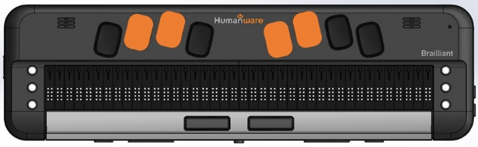

From the Brailliant Menu, press the letter **T**, you will be prompted “Terminal”.

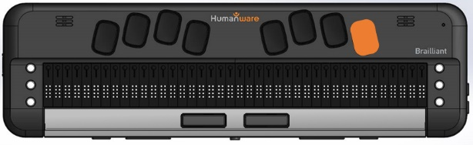

Now Press **Enter**.

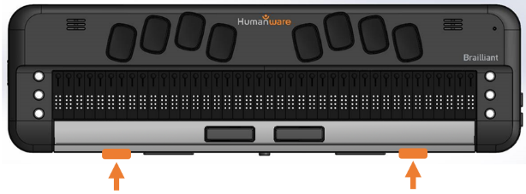

Use your **Previous** and **Next** thumb keys to move to “Add Bluetooth device”



Then press **Enter**.

You will be prompted “activate your device in your host device’s Bluetooth settings”, followed by the model and serial number of your device.

**Note:** The Brailliant will now be in a discovery mode state for 5 minutes. Once it exceeds this time the Brailliant will not be found, so it is recommended to perform the above actions again.

On your iPhone, open the Settings application from the home screen.

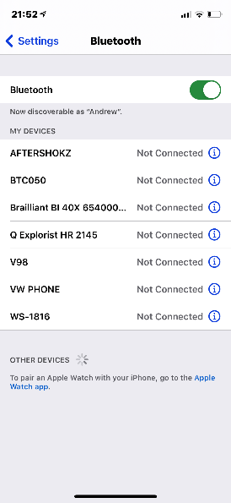

In settings, move to the Bluetooth Item and **double tap** to open.

Your Brailliant should be listed at the bottom section under “other devices”

Select the “Brailliant xxxxx” by **Double tapping** on the Brailliant Braille display.

The Brailliant will prompt you with “xxx connected”, where xx is the name of the iphone.

On the Brailliant you will be positioned in the connected devices. Use your **Previous** and **next** thumb keys to move through the list of connected devices.



Press **Enter** on the device you wish to connect to.

The Brailliant will now be connected as a braille display.

# Using Brailliant's keys

**Braille keyboard:**

Use the 8-dot Perkins Braille keyboard to enter text. The 8 keys of the Braille Keyboard are located above the Braille display. Some commands are also performed using Braille letters in combination with the Space bar. For example Space with the letter h will take you to the home screen.



**Command Keys: (Currently not mapped correctly with Apple)**

The six command keys are located on each side of the Braille cells, Dots 1-2-3 to the left and Dots 4-5-6 to the right. To do Command T, you have to press on Command keys 2-3-4-5 for the Braille letter T.

**Thumb Keys:**

The keys facing you are normally operated by your thumbs so we call them "Thumb Keys" to differentiate them from the main keyboard keys. Use the Thumb Keys for Braille navigation.

**Home Button:**

This key is positioned in the centre amongst the thumb keys and is circler shaped. Once connected to a host device, use this key to exit the connection and return to the list of connected devices. This also is used to return to the main menu.

### Brailliant iPhone commands

The below list describes all commands for the Brailliant to effectively control an iPhone.

*Please note some command keys are currently not active and are being investigated by Apple.

### Basic navigation commands

Move to previous item Command key 1 or Space with Dot 1

Move to next item Command key 4 or Space with Dot 4

Pan Braille to the left Command key 2 or Space with Dot 2 or Left thumb Key

Pan Braille to the right Command key 5 or Space with Dot 5 or right thumb key

Double-tap the selected item Space with Dots 3-6 or Routing cursor

Activate the Home button Space with H or Command H

Launch the App switcher Space with H or Command H twice quickly

Move to the first element Command keys 1-2-3 or Space with Dots 1-2-3

Move to the last element Command keys 4-5-6 or Space with Dots 4-5-6

Scroll left one page Command keys 2-4-6 or Space with Dots 2-4-6

Scroll right one page Command O or Space with O

Activate the Return key Space with Dot 8 or Command E

Activate a Back button if present Command B or Space with B

### Reading commands

Read page starting at selected item Command R or Space with R

Read page starting at the top Command W or Space with W

Scroll down one page Command keys 1-4-5-6 or Space with Dots 1-4-5-6

Scroll up one page Command keys 3-4-5-6 or Space with Dots 3-4-5-6

Pause or Continue speech Command P or Space with P

Speak page number or rows Space with Dots 3-4

### Information commands

Go to the Status bar Command S or Space with S

Start VoiceOver help Command K or Space with K

Quit VoiceOver help Command B or Space with B

Speak page number or

rows being displayed Command keys 3-4 or Space with Dots 3-4

### Rotor commands

Move to previous item using

rotor setting Command key 3 or Space with Dot 3

Move to next item using rotor setting Command key 6 or Space with Dot 6

Select previous rotor setting Command keys 2-3 or Space with Dots 2-3

Select next rotor setting Command keys 5-6- or Space with Dots 5-6

### Edit commands

Select text Command keys 2-5-6 or Space with Dots 2-5-6

Unselect text Command keys 2-3-5 or Space with Dots 2-3-5

Select all Command keys 2-3-5-6 or Space with Dots 2-3-5-6

Cut Command X or Space with X

Copy Command C or Space with C

Paste Command V or Space with V

Activate the Delete key Command D or Space with D

Activate the Return Key Space with E

Redo Command keys 2-3-4-6 or Space with Dots 2-3-4-6

Undo Command Z or Space with Z

Tab Space with Dots 2-3-4-5

Shift Tab Space with Dots 1-2-5-6

Text search Space with F

Start dictation when in text field Space with Dots 1-5-6

### Miscellaneous commands

Activate the Volume Up button Command keys 3-4-5 or Space with Dots 3-4-5

Activate the Volume Down button Command keys 1-2-6 or Space with Dots 1-2-6

Switch between 8 and 6 dot Braille Command keys 2-3-6 or Space with Dots 2-3-6

Toggle speech on and off Command M or Space with M

Toggle Screen Curtain on and off Command keys 1-2-3-4-5-6 or

Space with Dots 1-2-3-4-5-6

Toggle QuickNav Space with Dots 1-2-3-4-5

Change an Item’s label Space with Dots 1-2-3-4-6

Switch between contracted and

uncontracted Braille Command G or Space with G

Toggle expanded status description

when Status cells are activated Status Routing cursors

Activate the Tab key Command T or Space with T

Activate the Shift with Tab keys Command keys 1-2-5-6 or Space with Dots 1-2-5-6

Toggle announcement history Command N or Space with N

Activates the Eject key Command keys 1-4-6 or Space with Dots 1-4-6

Show/Hide the Keyboard Space with Dots 3-5-6

Rev 01