APH Factory Reset Procedure

- Before executing the Factory Reset of the tablet make sure that any Google accounts that are active on the tablet are removed by going into Settings -> Accounts -> selecting Google -> tap on the three dots on the top right of the screen and select Remove Account.
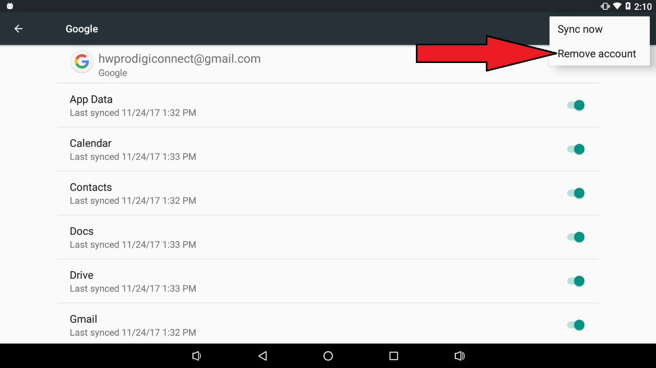

- Once the accounts removed go back to settings and tap on Backup & Reset –> Factory data reset -> REST TABLET -> ERASE EVERYTHING. The tablet will reboot.

- Once the tablet is rebooted go thru the tutorial to setup the language, Wi-Fi and accounts. If a prodigi update popup appears, select cancel for now.

- When the setup tutorial if finish, the developer options need to be activated by going into settings -> about tablet -> Click 7 times on “Build number” at the bottom of the list.

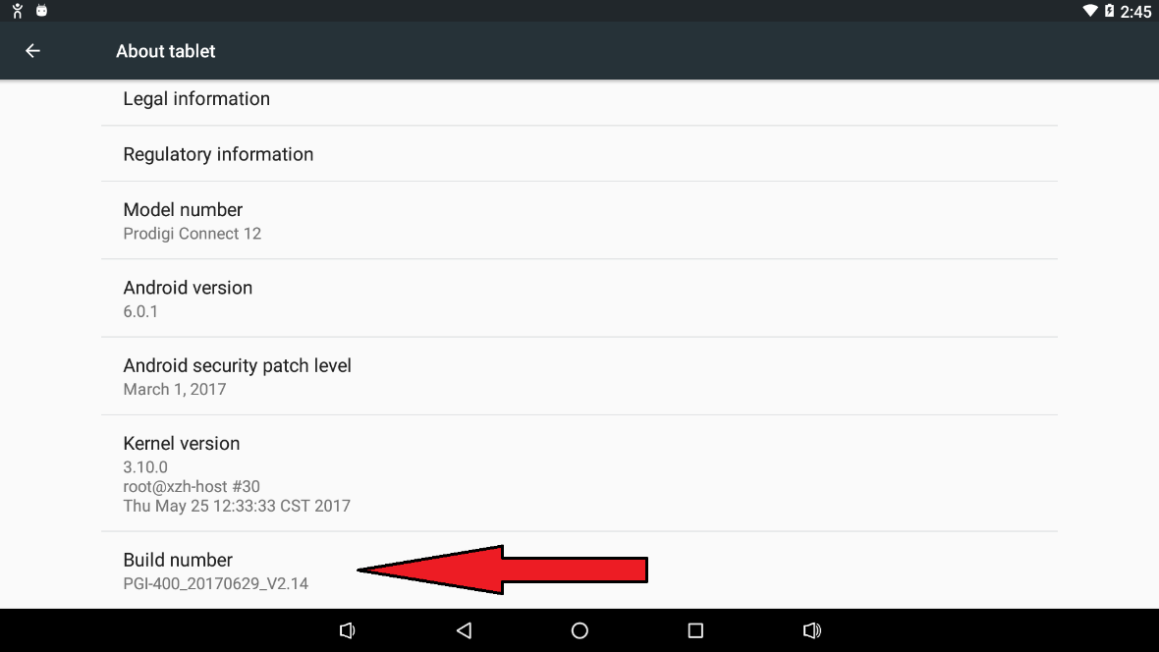

- Then go back in settings and select Developer options –> Enable USB debugging, tap ok on the pop up.
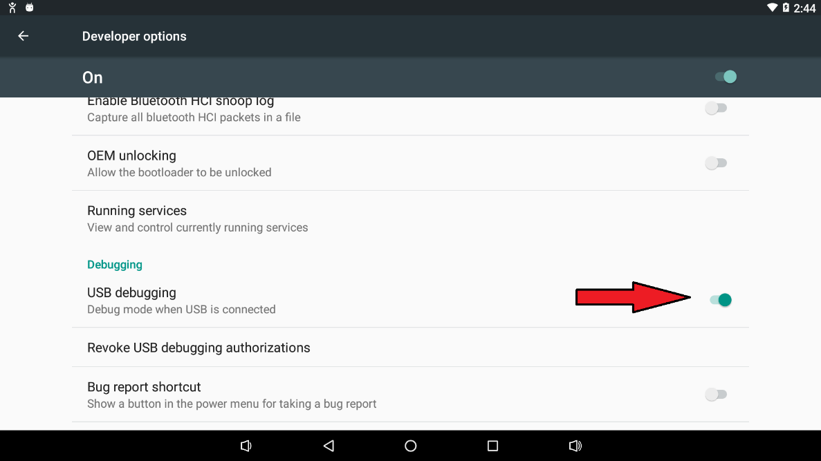

- Connect the tablet to a computer and check the check box: “Always allow form the computer”, then click ok on the pop up window.

- Go into the application window and tap on the Prodigi Updater icon, this will install the prodigi suite. Tap on install.

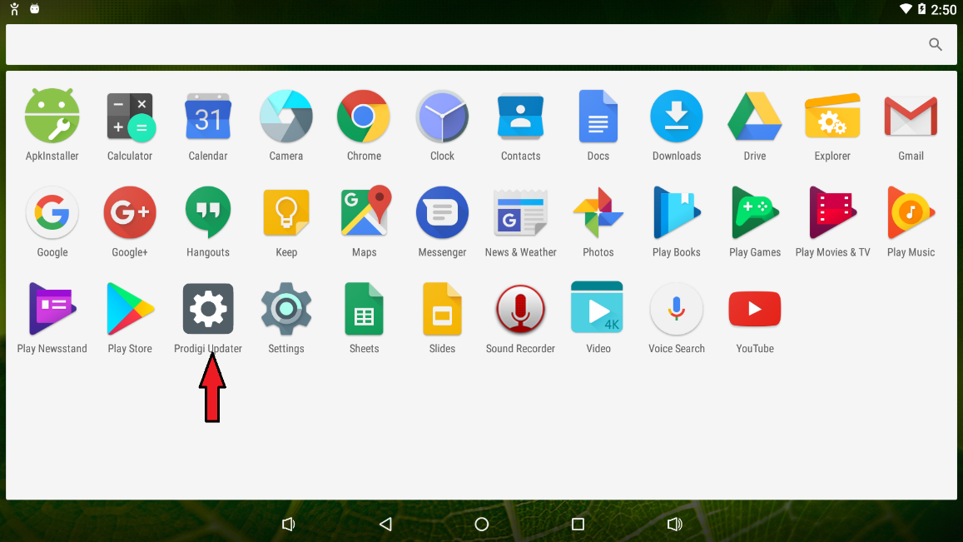

- When prodigi is finish installing, execute the InstallAppsForAPH.bat file by double clicking it from the connected computer. This will install all the APH applications. To get the InstallAppsForAPH.bat file, you need to extract the InstallAppsForAPH.zip file to the connected computer. You can not execute the InstallAppsForAPH.bat file if the file zip file is not extracted. Go to step 9 to learn how to extract the file.

- Copy the zip file in a folder on the connected PC.

- Right click on the file and select Extract All. This will extract the file in the folder.
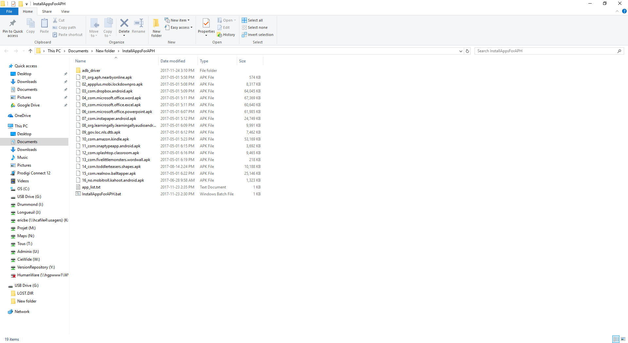

- In the extracted folder the file InstallAppsForAPH.bat will be found.

- To install the APH applications double click on the InstallAppsForAPH.bat file this will open a cmd prompt windows.

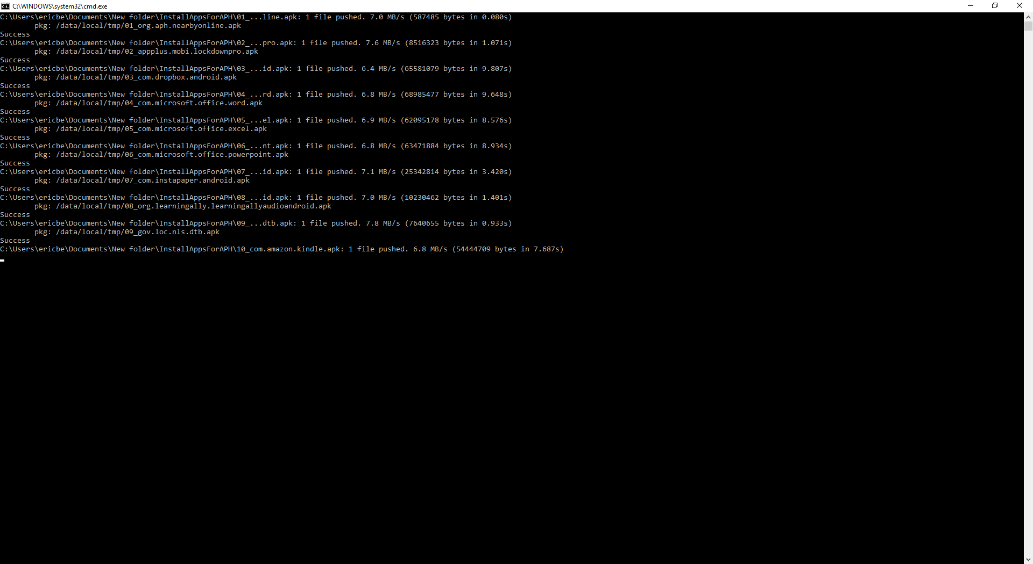

- If the following window appears on the tablet check the check box: “Use by defaults for this USB device” and then tap ok.

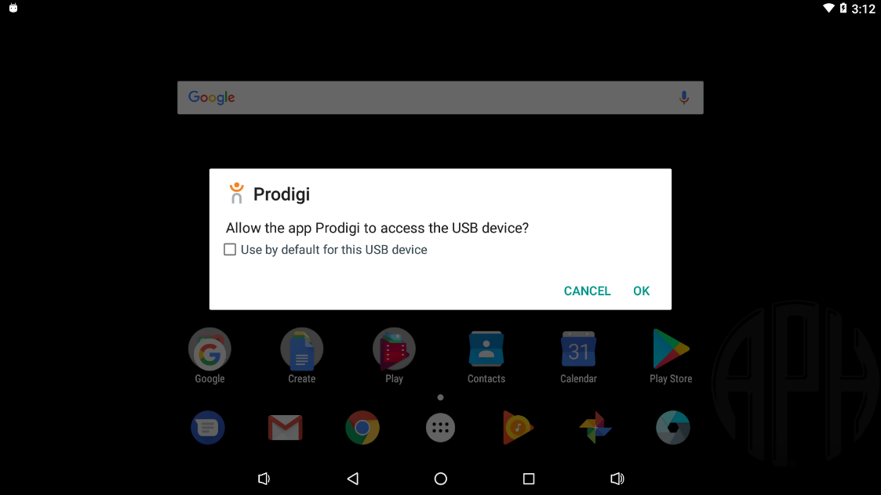

- Prodigi can be started and the applications should be all install

- The applications on the tablet desktop can be rearrange as below by dragging the applications to the correct positions and to create a tech.aph.org/hw/ bookmark on the desktop Chrome needs to be started, the address tech.aph.org/hw/ needs to be inputted in the address field of chrome then select “Add to Home screen” from the three dots at the top right of the chrome window.
