Installing an update on your explorē 12 device

- Download the explorē 12 software update files.

- Using the USB cable supplied with your explorē, connect the device to the computer where the software update files are downloaded.

- Copy the downloaded BRN file to the root of the device.
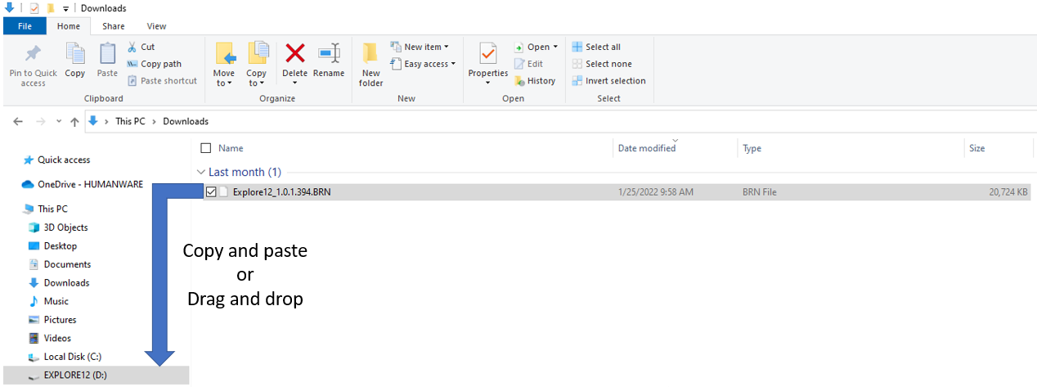
- Disconnect the explorē 12 from the computer and remove the USB cable.

- Turn the unit on by pressing the power button.

- “Software Update” will appear on the device’s screen and the update will complete.

- Validate the software matches the BRN file version number in Settings -> About.

