Getting Started Guide

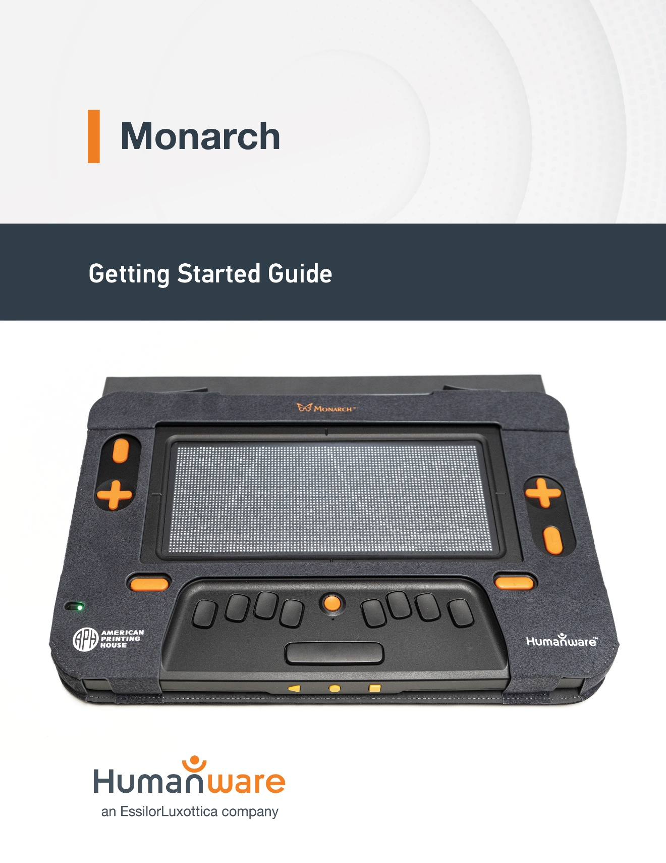**Version 1.1**

# Getting Started

Thank you for purchasing the Monarch, the first ever dynamic tactile device that brings both Tactile graphics and braille on the same tactile array in addition to showing true multiline braille. Below, you will find instructions to begin using your device quickly and comprehensively.

To know more about the different functions and apps present on this tablet, and to read all the details about the navigation on your tablet, please read the User guide included in the device. To open the User guide, when on the Keysoft’s Main menu, press the letter A to navigate to All applications and press Enter to select it. In the All applications list, press Enter on the User guide app, and the user guide will open. You can also read the user guide via our website.

# In the Box

The package contains the following items:

* Monarch Tablet in its protective case
* Power Adaptor
* Type-C USB Cable
* Quick start guide (printed and Braille)
* Envelope containing 5 membranes
* M10 Screw Driver for Membrane
* Tactile QR Code sticker for additional resources, located on the top right corner of lid inside of box and an additional one with this guide, for you to place where you like.

## Important notes

* When you receive your Monarch, it will be encased in a protective bubble sleeve. To use the tablet, gently remove the Monarch from the sleeve. Remember to retain all packaging in case the need arises to return the Monarch.
* External magnets may interfere with the performance of the braille pins, leading to incorrect content being displayed.
* Operating temperature range:  0-40°C
* The Braille Cells are protected by a replaceable membrane. Replacement procedure and membrane care is located in the user guide.

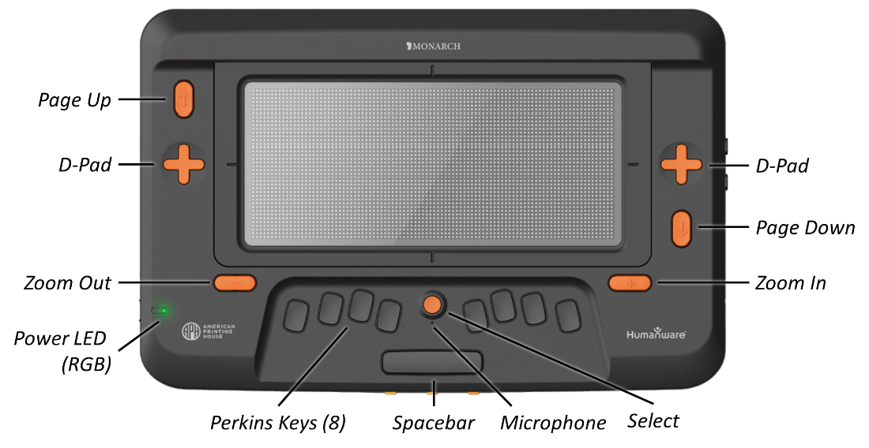

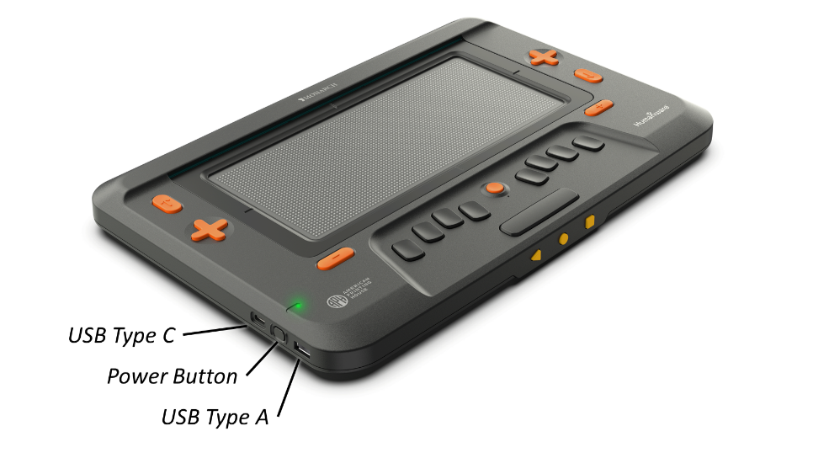

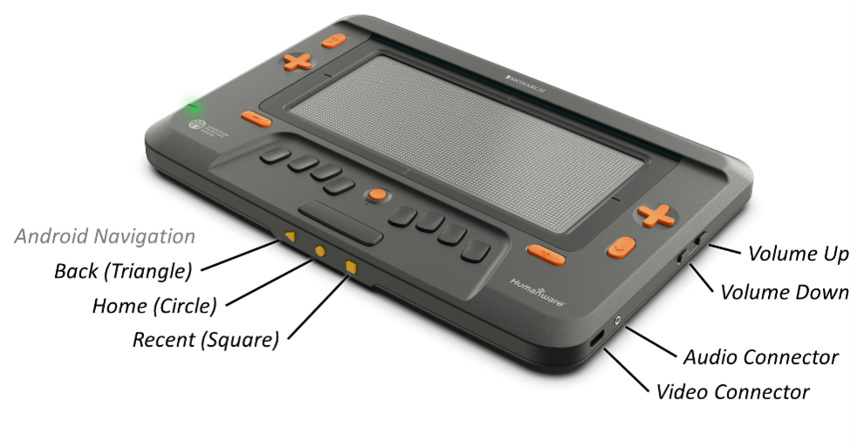

# Recharging your Monarch

Before using your Monarch for the first time, it is highly recommended to fully charge it. To do so, plug in the type-C USB connector of your recharge cable into the Type-C USB port located in the rear of the left edge of your Monarch. Since this is a type-C USB connector, you don't have to worry about plugging it upside down.

If this isn’t already done, plug in the USB connector of your recharge cable into the power adaptor, then plug the power adaptor into a power outlet.

Alternatively, you can plug your USB connector into a computer, but note that this method of charging is slower than charging with a power adaptor.

Please note: a full charge of the Monarch typically takes 4 hours with the provided power adaptor. When fully charged, the device will work a full day.

# The first boot of your Monarch

When you are ready to boot your Monarch for the first time, press and hold the Power button for 2-3 seconds. The power button is oval-shaped and is placed at the left of your device, in the middle, between the USB-C port upward and the USB-A port downward. You will feel a quick vibration, and after 7 to 8 seconds, you will see “starting keysoft...” on the Braille display, followed by the butterfly image. A few moments after you first boot your device, you will be welcomed with a language selection screen. Navigate through the list of languages with the D-pads and panning keys, then select the language of your choice by pressing on the Enter key when you are positioned on the desired line. Then, you will wait a few seconds and the startup tutorial will be launched. This startup tutorial will teach you the basics of your Monarch: the navigation keys, the tactile viewer and the reading of text. When the startup tutorial is finished, or if you decide to exit this tutorial, you will be directed to the Main menu.

Note: the startup tutorial will be launched if it is available using the language you have selected. If it is not the case, you will be directed to the Main menu after the language selection.

**ACCD-0318  
REV 000**