# Membrane Replacement Instructions

Step 1 : If applicable remove the Monarch from the Case. Place your unit upside down on a flat and clean surface.

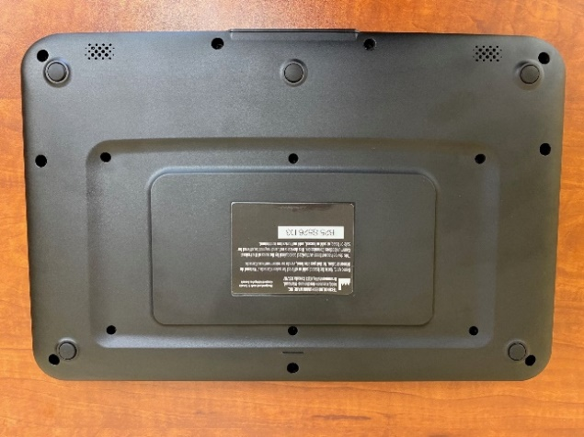

Step 2 : With a Philips #1 screwdriver, remove all the 6 screws that lies within the back recess.

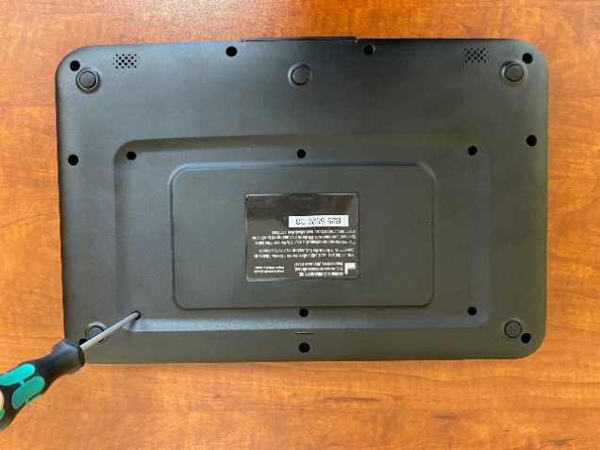

Step 3 : Lift the device and the frame should fall out of the unit. Otherwise, frame can be removed manually by hand. Take extra care not to touch the exposed braille display.

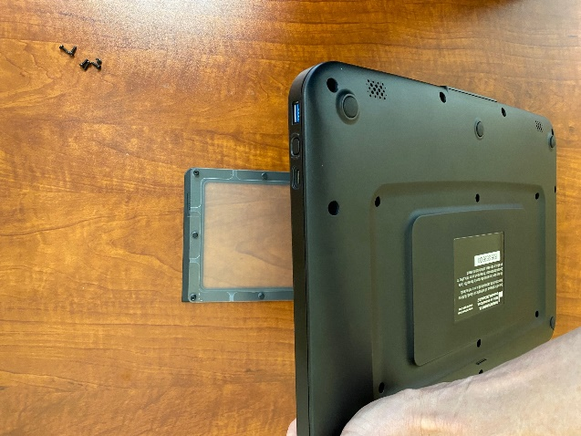

Step 4 : Remove the old membrane from the frame by sliding out each holes from its stud.

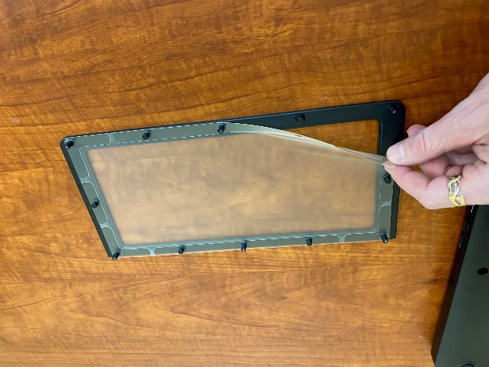

Step 5 : On the new membrane, remove the protective film.

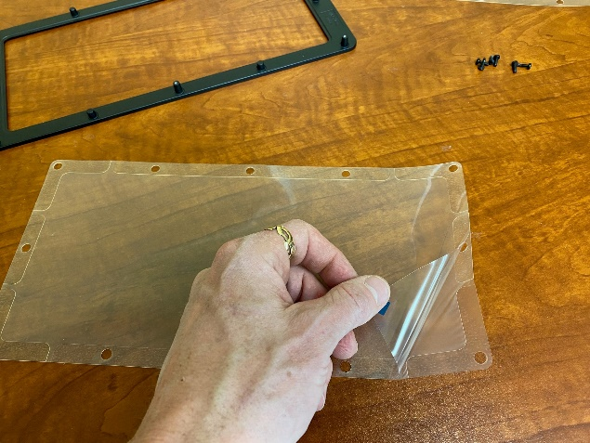

Step 6 : Place the membrane over the frame with the hard plastic facing towards the frame. The protective film face should be facing you. Align the holes around the membrane with the studs of the frame. Slide them in one at a time. The membrane can be stretched during the alignment.

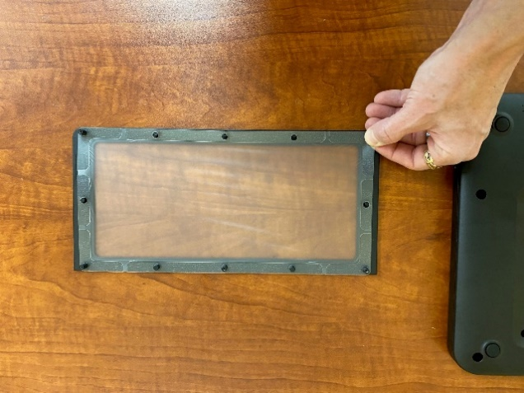

Step 7 : Make sure that the membrane is completely seated at the bottom of the frame and is clean from foreign objects.

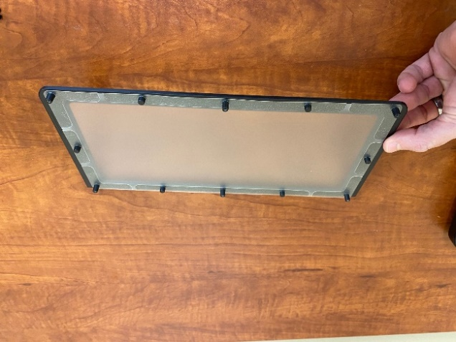

Step 8 : Gently put the frame and membrane assembly back on the top of the unit. Be careful of the frame orientation placement.

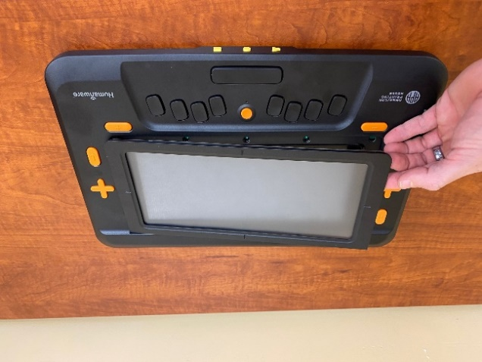

Step 9 : Flip the unit upside down whilst maintaining the membrane frame in place by holding with your fingers. Put back the 6 screws and tighten them with a torque of 3.2 kgf-cm.

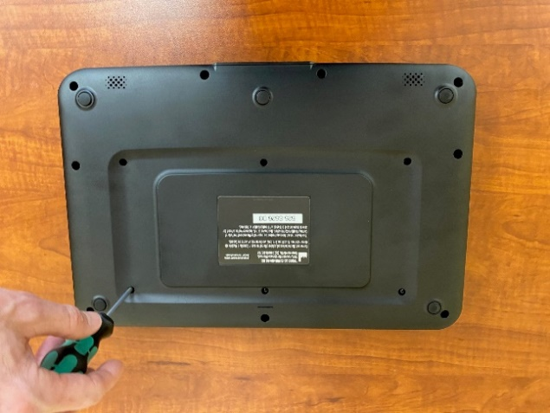

Step 10: Use your device with a smile!!